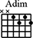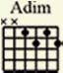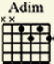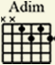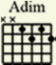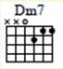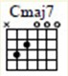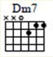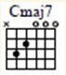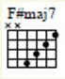MISTLETOE AND HOLLY

A E7 A
Oh, by gosh, by golly,

Bm7 E7
It's time for mistle toe and holly,

A E7
Tasty pheasants, Christmas presents,

Bm7 E7 A Countrysides covered with snow.

A E7 A
Oh, by gosh, by jingle,

Bm7 E7
It's time for carols and Kris Kringle,

A E7
Over - eating, merry greetings

Bm7 E7 A
From relatives you don't know.

G7
Then comes that big night,

G7
Giving the tree the trim;

G#m7 C#7
You'll hear voices by starlight

F#m7 B7 E7
Singing a Yuletide hymn.

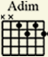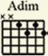A E7 A
Oh, by gosh, by golly,

Bm7 E7
It's time for mistle toe and holly,

A E7
Fancy ties an' granny's pies,

Bm7 E7 C#7 F#7
An' folks stealin' a kiss or two

B7 E7 A
As they whisper, "Merry Christmas" to you.

repeat from bridge to end

