Father of Our Nation

Intro
|D D . D D . . .|. . . . . . . .| (4 times)
|D D . D D . . .|. . . . . . . .| (2 times)
Oh way too, oh way too dah dah

Then repeat this throughout song
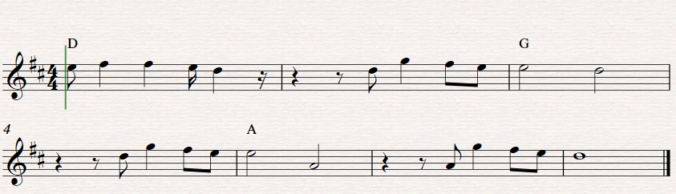

|D D . D D . . .|. . . . . . . . | (4 times)
Oh way too, oh way too dah dah

