Wintersong

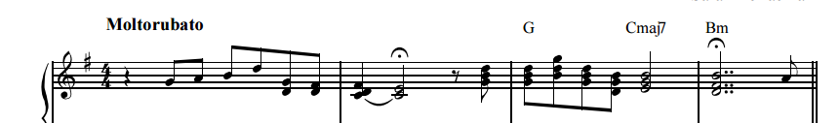

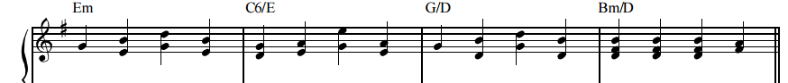

Em C6 G Bm
The lake is frozen over The trees are white with snow

Em C6 G Bm
And all around Reminders of love Are everywhere I go

Cmaj7 Em Cmaj9 G D
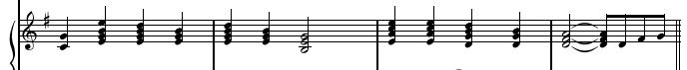

Oooo … oooo ….

Em C6 G Bm
It's late and morning's in no hurry But sleep won't set me free

Em C6 G Bm
I lie awake and try to recall All the things you’ve done for me

Cmaj7 Em Cmaj7 D
When silence gets too hard to handle And the night too long

C G
And this is how I see you
C D
In the snow on Christmas morning
Em C G
Love and happiness surround you
D
And I throw my arms up to the sky
Em
I keep this moment by and by

C G
Oh I can see you now, mmm
Em C6
Merry Christmas, merry Christmas,
G Bm
Merry Christmas, to all

Em C6
A sense of joy fills the air
G Bm
And I daydream and I stare
Cmaj7 Em C D
Up at the tree and I see Your star up there

C G
And this is how I see you
C D
In the snow on Christmas morning
Em C G
Love and happiness surround you
D
And I throw my arms up to the sky
G
I keep this moment by and by

Wintersong

The lake is frozen over
The trees are white with snow
And all around Reminders of love
Are everywhere I go
Oooo … oooo ….

It's late and morning's in no hurry
But sleep won't set me free
I lie awake and try to recall
All the things you’ve done for me
When silence gets too hard to handle
And the night too long
And this is how I see you
In the snow on Christmas morning
Love and happiness surround you
And I throw my arms up to the sky
I keep this moment by and by

Oh I can see you now, mmm
Merry Christmas, merry Christmas,
Merry Christmas, to all

A sense of joy fills the air
And I daydream and I stare
Up at the tree and I see
Your star up there

And this is how I see you
In the snow on Christmas morning
Love and happiness surround you
And I throw my arms up to the sky
I keep this moment by and by

